Sweep a selected sketch along a path or to other profiles
This request aims to stabilize this function. I provide this for any use you feel usefull.
First FreeCAD version
OS: Windows 7
Word size of OS: 64-bit
Word size of FreeCAD: 64-bit
Version: 0.18.15007 (Git)
Build type: Release
Branch: master
Hash: 70fef3934190aabc61f5e1346483359d5ad21403
Python version: 2.7.14
Qt version: 4.8.7
Coin version: 4.0.0a
OCC version: 7.2.0
Locale: French/France (fr_FR)
The intention is to make something like this:

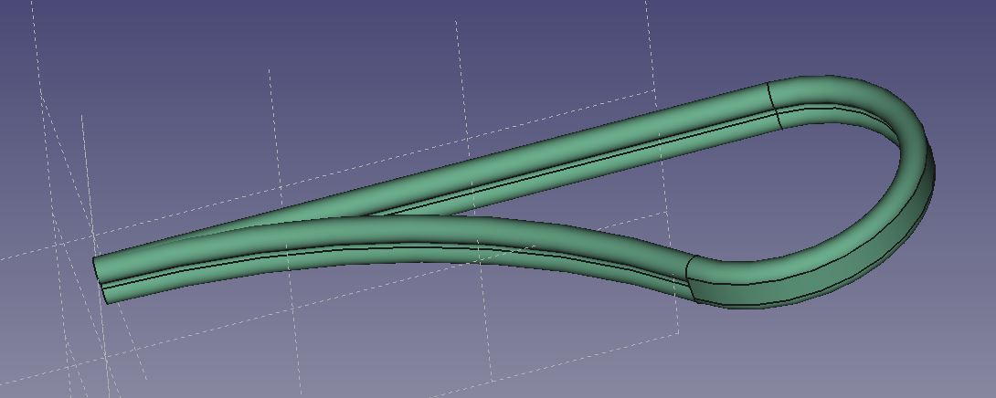
But this is not exactly what I wanted, I will explain later.

1 - The shape to extrude (SketchProfile):
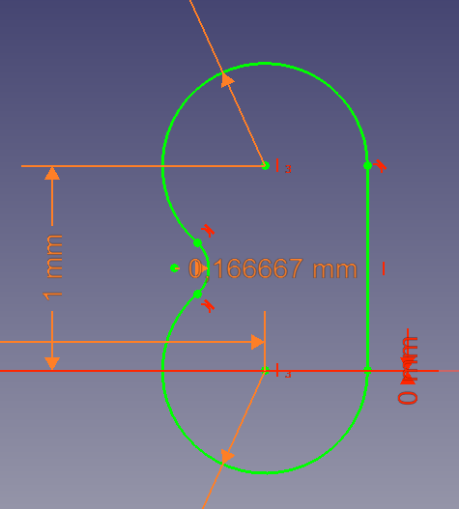
2 – The path along which I want to extrude (SketchPath).
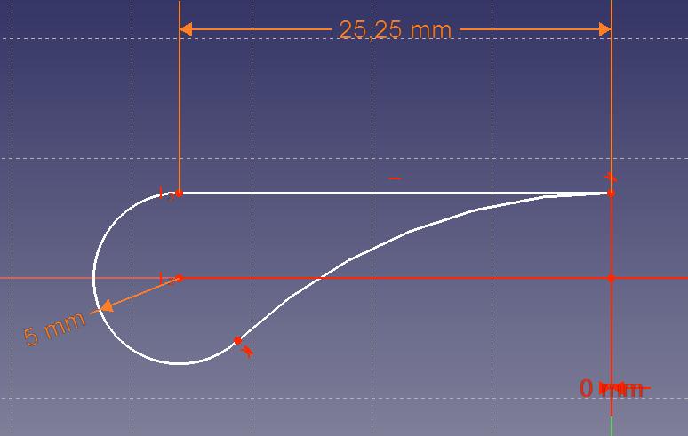
Notice the path is closed, but at right side the two ends oriented the same way and tangent.

3 – Now building the object:
Selecting SkectchProfile and clicking the tool in Part design workbench.
I have at this stage to make SkechPath visible.
Then in the task panel 2 times click on Add Edge and click on the edge on the view (the long one first, the curved one after.
The preview look like this what is exactly what I expect at this stage: The flat side outside.

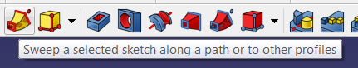

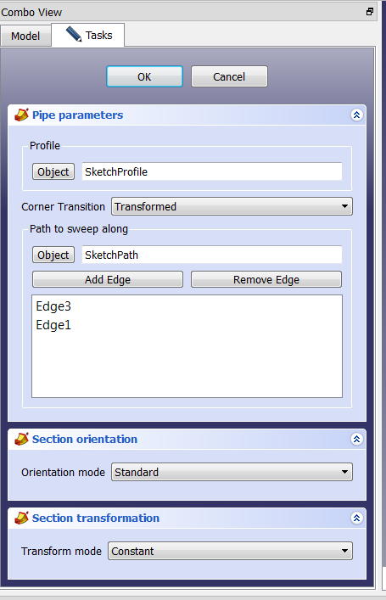
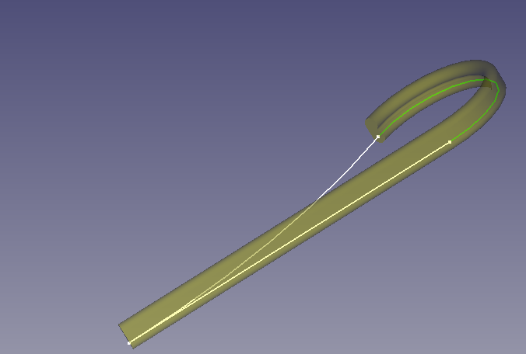
Then I add the last edge, and then the result is completely changed. The flat side is set inside all along the path, in this try. Even the two first segments have been reversed.
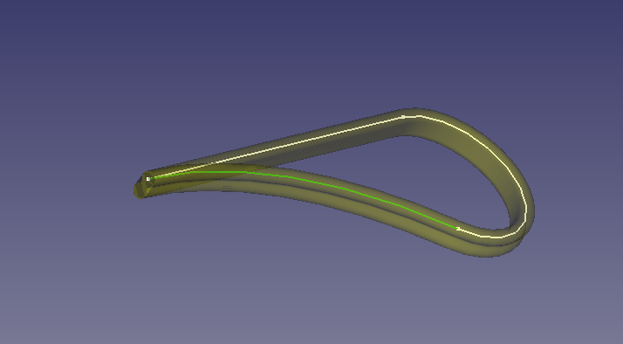

I tried to change corner transition to something else, but FreeCAD entered in an infinite loop, and I add to kill the process, what is really a problem.

I have obtained other behaviors as the one shown at first image, what is not what I want.
The result is somehow unpredictable.

When clicking OK, I have got different results without understanding the conditions and what introduces these ifferences:
- A pipe (not solid)
- A solid
- A solid but the last part (corresponding to Edge 2) removed for the result.

Now the questions and remarks:
- What do I do wrong? (just in case I missed something)
- Should not for each edge add a boolean (reverse) to define in what direction it is to be gone throw, what will help to decide the direction of the normal vector?
- Obviously, the algorithm for rendering the preview is not the same as the algorithm for the final rendering, especially on the positioning. I do not understand what the logic for translating the sketch extruded is. Translating of not this shape has almost no effect. It would be good to clearly identify the point of the shape that will be kept on the path.
- test2 is build on test. I changed the position of SketchProfile and build another pipe. The first pipe has now errors that I cannot identify. Changing the profile to be extruded should change the shape but not induce errors!

I can help you in reproducing the case if needed.
Regards
Pascal Garcia

